**Appendices I**

**Inheritence**

As outlined in Appendices B within the descriptions of the classes to be developed, I designed a super class called AgreementImpl, which hold generic fields and methods for an account, and I have then created TenancyImpl, LeaseImpl and ContractImpl which all extend AgreementImpl and therefore re-use the code of the AgreementImpl class. Furthermore, by developing sub classes that inherit from a super class, it allows the programmer to make use of polymorphism, which is outlined below.

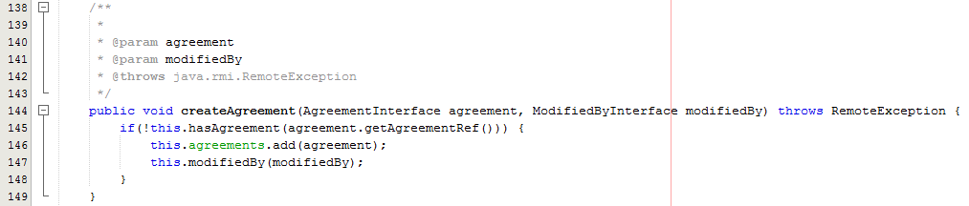

Fig. 1 – Extract from Database, updateUserAgreements() method

As you can see from Fig. 1, the Office class has made use of polymorphism by having a List of agreements which can hold any type of agreement, whether it be a tenancy, lease or contract and within the createAgreement() method, you can see that the office class invokes Agreement.getAgreementRef() on any of the Agreement elements, again whether it be a tenancy, lease or contract.